Human Impacts on the Earth’s Environment

Earth Science Study Guide Study GUide

Global Warming

Study Tip

Global Warming

Think about greenhouse gasses as a large blanket. It traps warmth and keeps it from escaping.

* **Global warming** is the gradual warming of the Earth due to the trapping of greenhouse gasses primarily released by human activity.
* 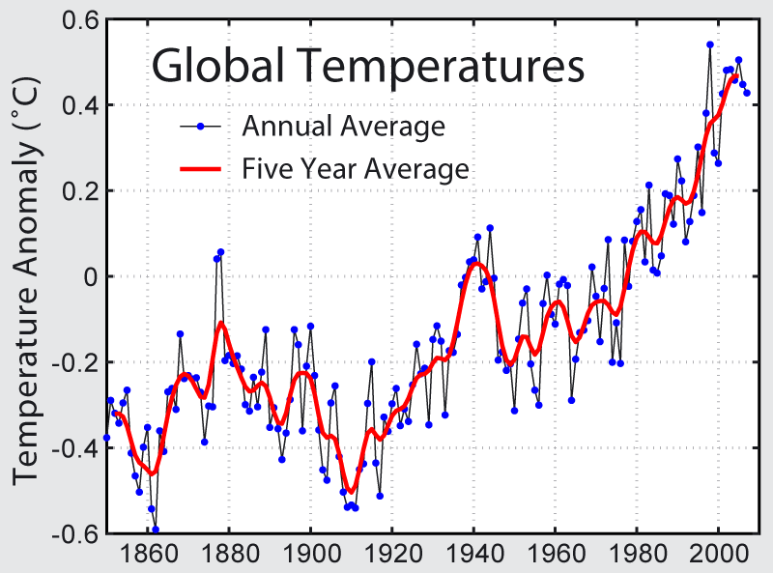The rate that temperature has been increasing has been greatest within the past century.
  + The 2000s have been the warmest decade recorded.
* Gases such as carbon dioxide enhance the greenhouse effect and causes global temperature to increase

Changes

* The timing for the events of species is changing.

The global temperatures continue to rise as global warming occurs.

* + For instance, mating and migrations take place earlier in the spring months due to the changing temperatures.
* Sea levels are rising due to the ice caps melting.

Concept Check

* How does the Earth’s temperature change due to global warming?
* What other effects does global warming have on the Earth?